

**WEBTECH FINAL PROJECT**

**Project: Keza Cars**

**Project Requirements**

* **Purpose:** The purpose of this project is to develop a car sales management system that will provide businesses with a user-friendly platform to manage the sales process of vehicles, manage their cars inventory and provide better customer service.
* **Expected Outcomes:** The expected outcomes of this project are as follows:
  + A user-friendly platform that is easy to use for businesses of all sizes.
  + A system that can manage customer information, including the ability to store and update customer contact information.
  + A system that can manage cars inventory, including the ability to track the availability of cars, set prices, and track sales.
  + A system that can provide better customer service, including the ability to track customer inquiries and provide support.
* **Constraints or Limitations:** The following are some of the constraints or limitations of this project:
  + The system must be compatible with the existing systems used by businesses.
  + The system must be secure and protect the privacy of customer data.

**Project Plan**

* **Scope:** The scope of this project includes the development of a car sales management system that will provide businesses with the following features:
  + A user-friendly platform that is easy to use for businesses of all sizes.
  + The ability to manage customer information, including the ability to store and update customer contact information, purchase history, and preferences.
  + The ability to manage cars inventory, including the ability to track the availability of cars, set prices, and track sales.
  + The ability to provide better customer service, including the ability to track customer inquiries and provide support.
* Timeline: The project was done in 2 weeks

**Project Requirements**

* Authentication and Authorization:
* The project implements authentication and authorization functionality using Spring Security.
* The project provides features such as user registration, and role-based access control.
* Validation:
* The project validates user input using Spring Validation.
* Pagination:
* The project implement pagination for database queries using Spring Data JPA.
* The project splits large amounts of data into smaller chunks to improve performance.
* Error Handling:
* The project handles errors and exceptions gracefully using Spring MVC's exception-handling mechanism.
* The project catches and handle exceptions and display appropriate error messages to the user.
* Spring Security works, for example, when a user tries to access a protected part, Spring Security will check if the user is authenticated. If the user is not authenticated, Spring Security will redirect the user to the login page.
* Once the user is authenticated, Spring Security will check if the user has the necessary permissions to access that part. If the user does not have the necessary permissions, Spring Security will deny the request.

**Below are screen shots of the running project:**

**This is the home page;**

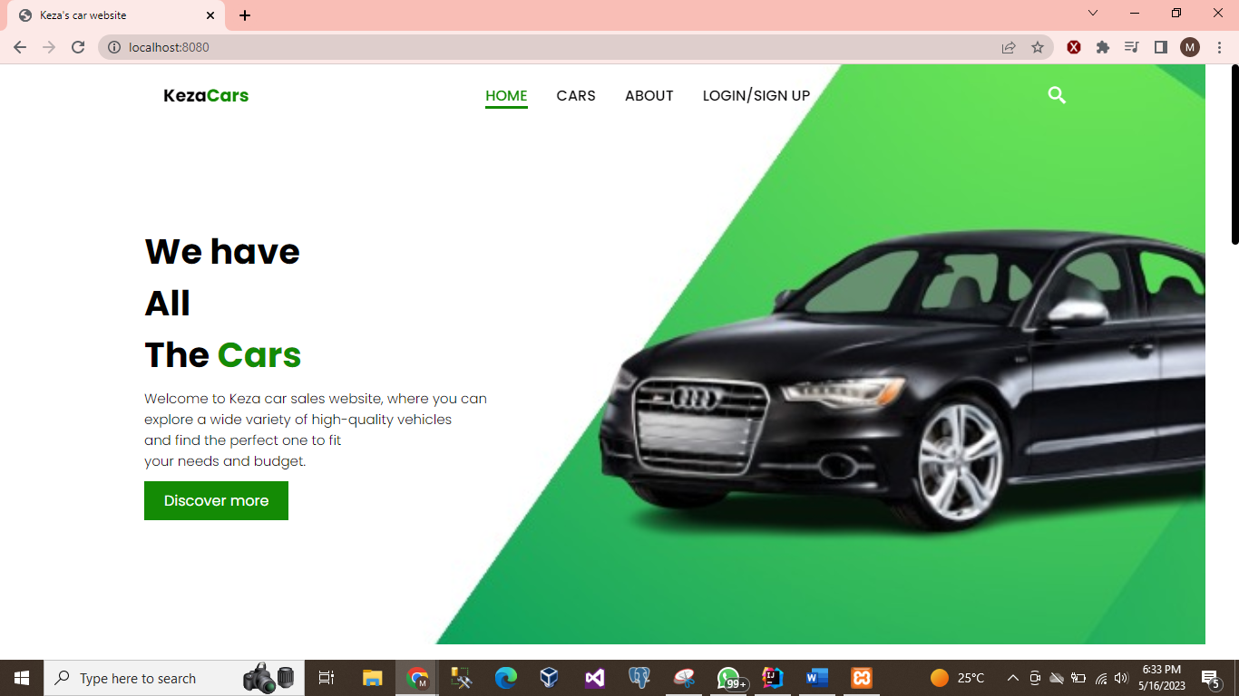

**About us**: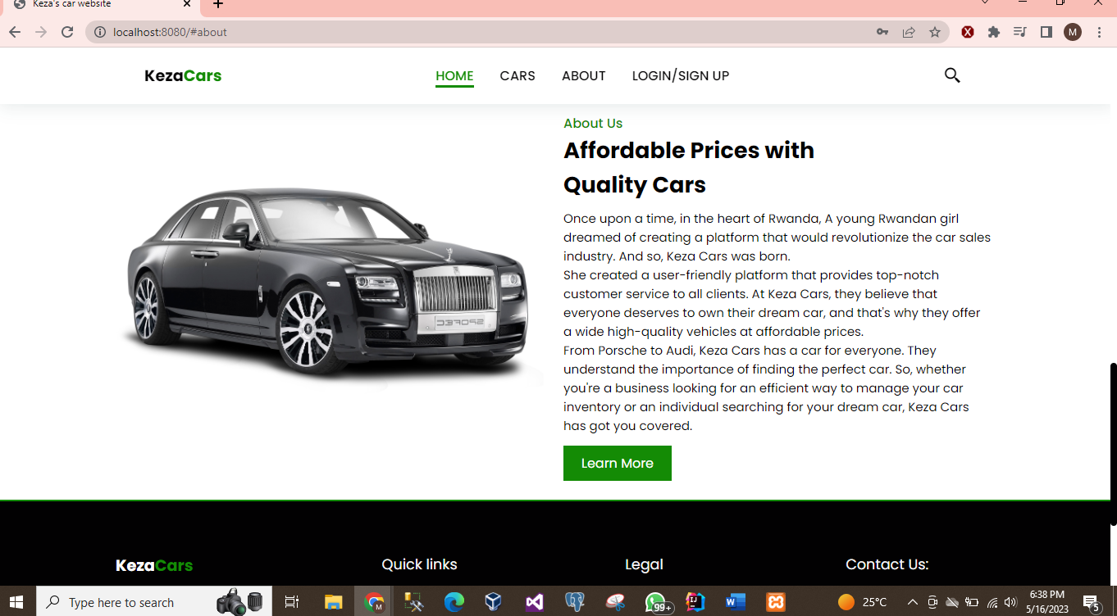

**The footer:**

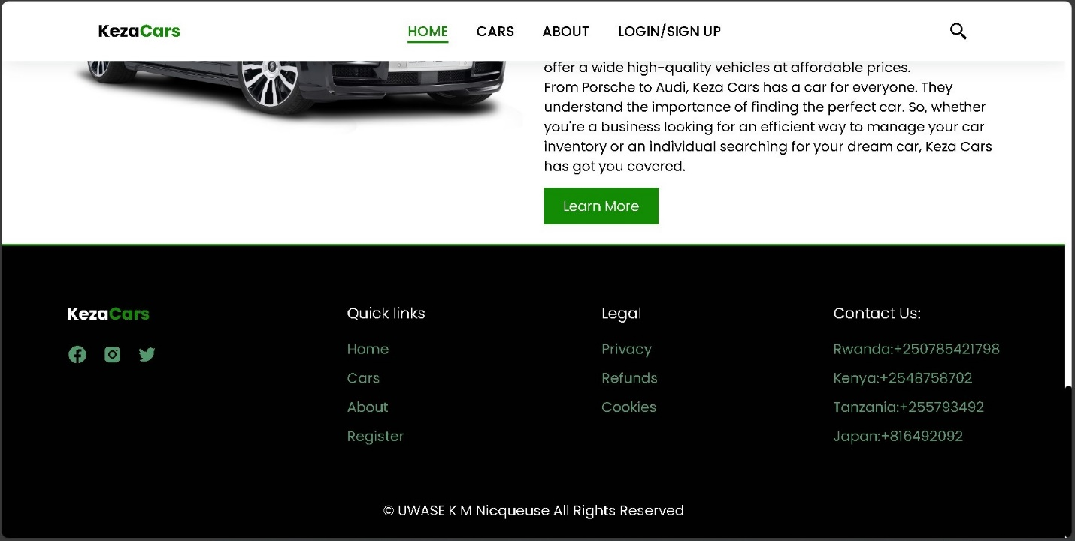

**Cars section:**

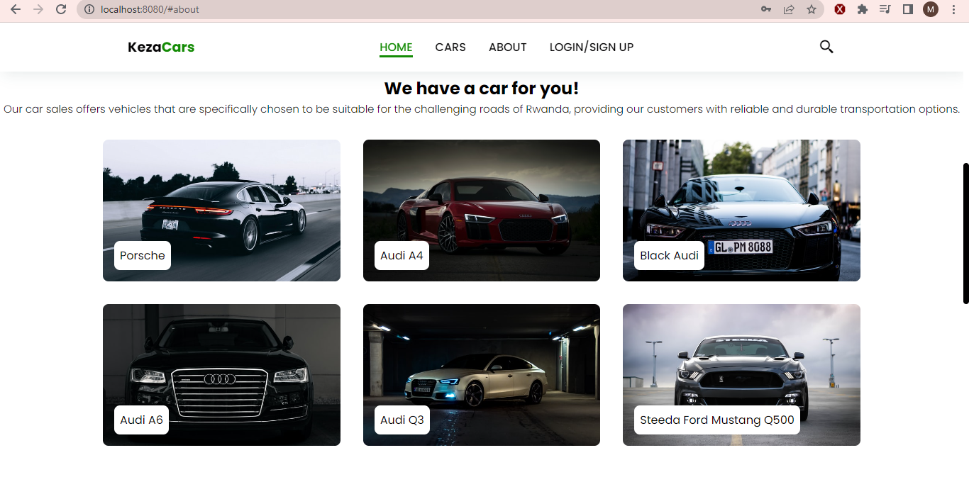

**Login and Sign up:**

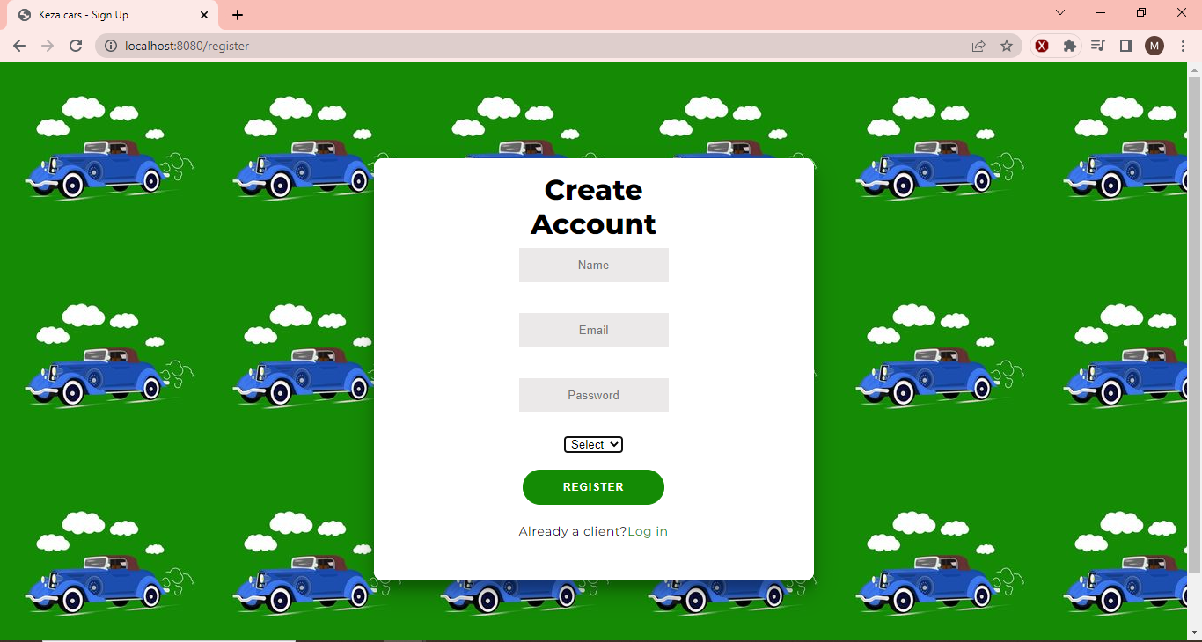

**Validation:**



**When Admin logs in:**

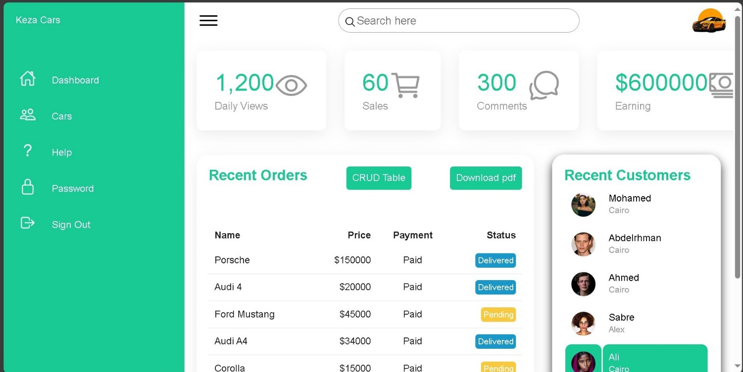

**Crud table is accessed by button CRUD:**

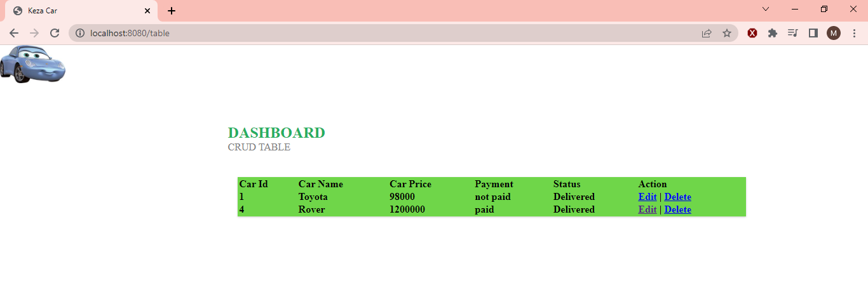

**Customer when logged in can see past reviews:**

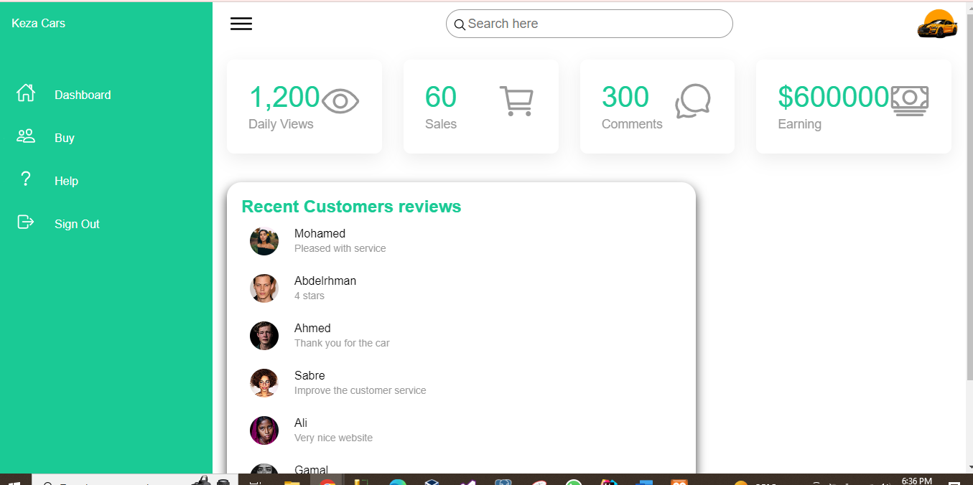

**Here they click on buy and see the cars available:**

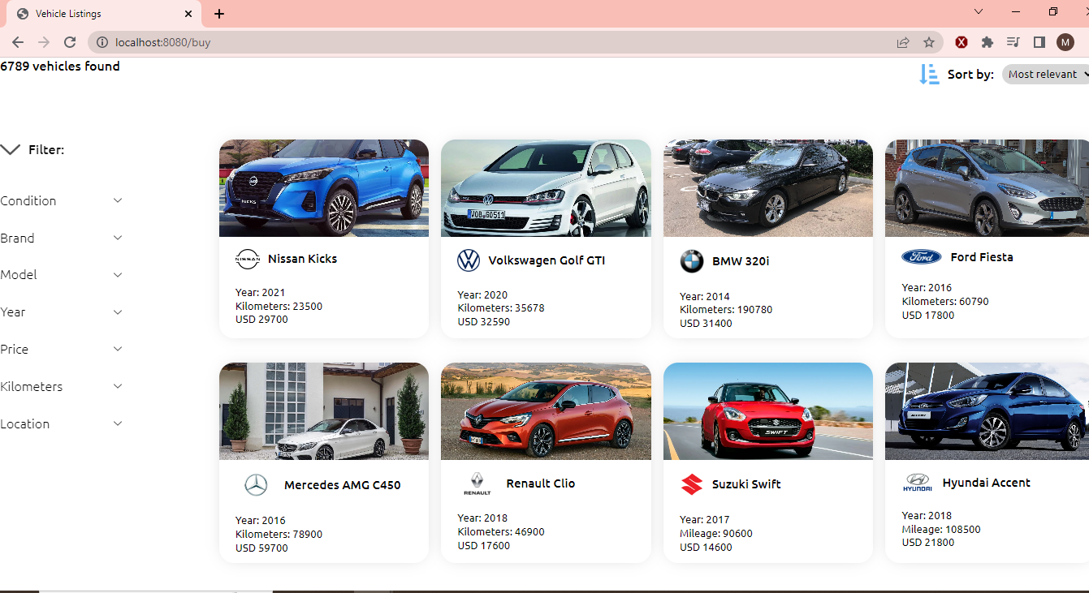

**Then when a specific car is clicked:**

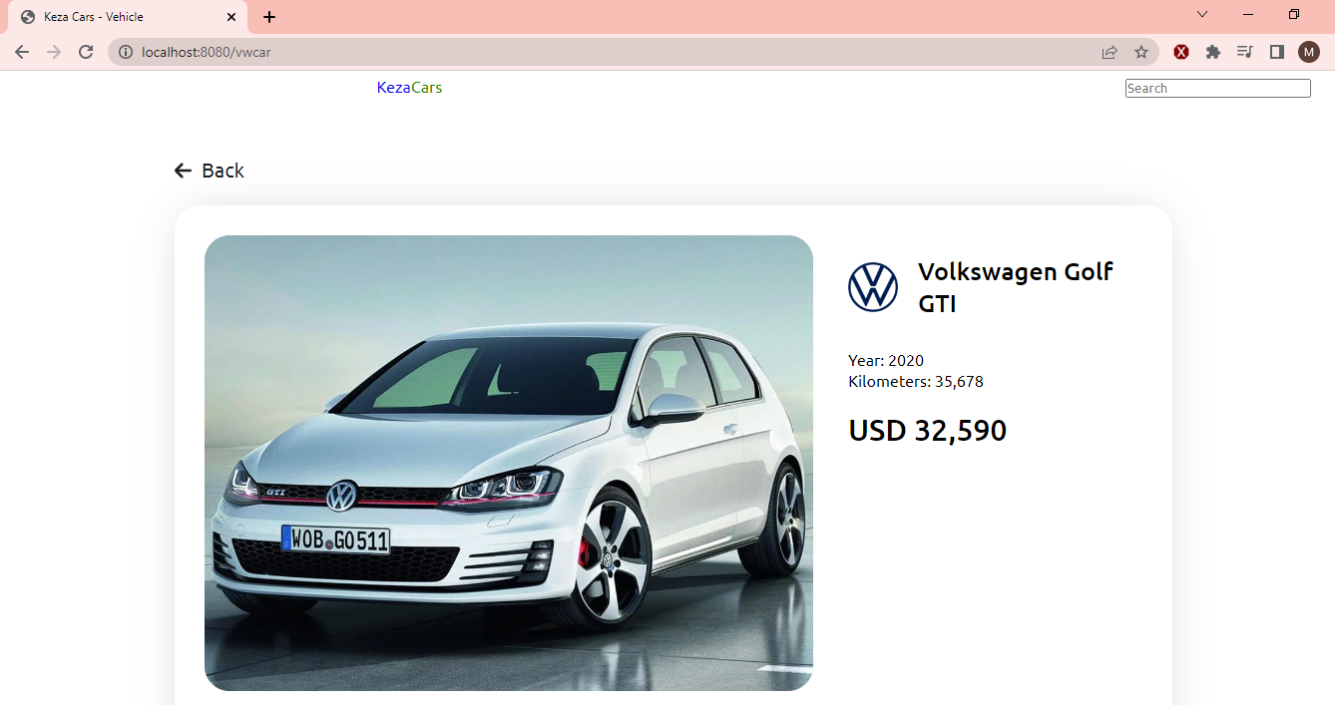

**Below it is a purchase button:**

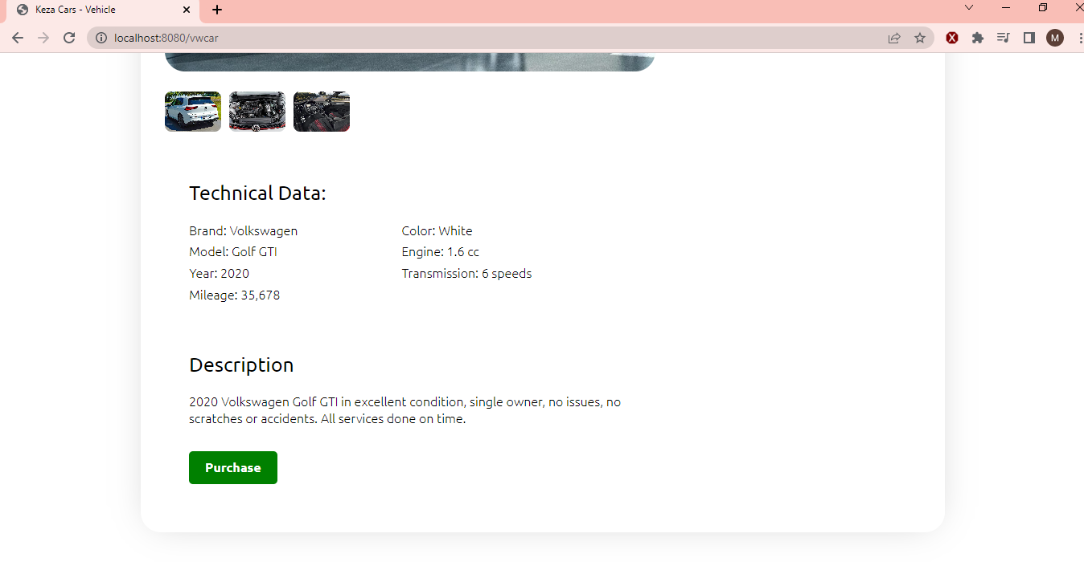

**Then proceed to payment:**

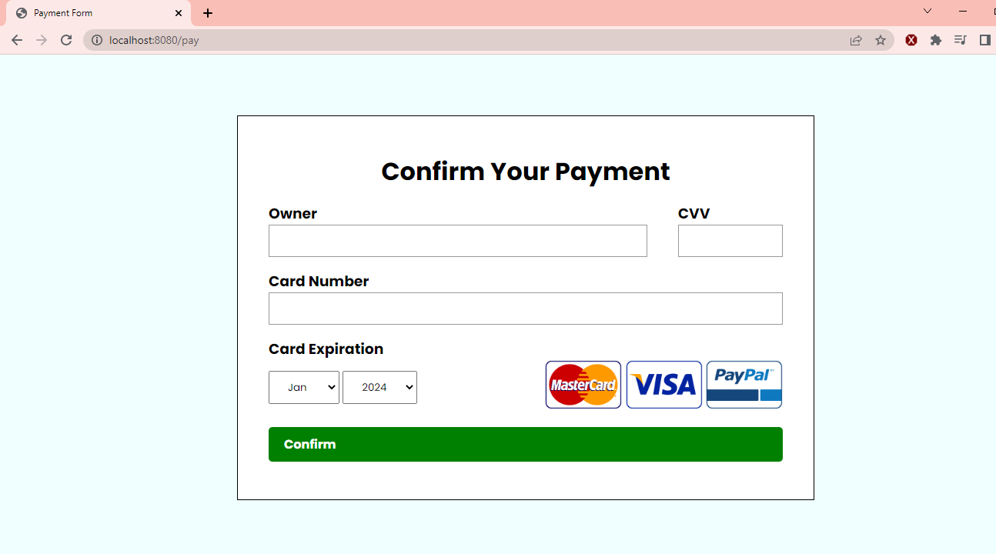

**Then a good bye message which takes you to home:**

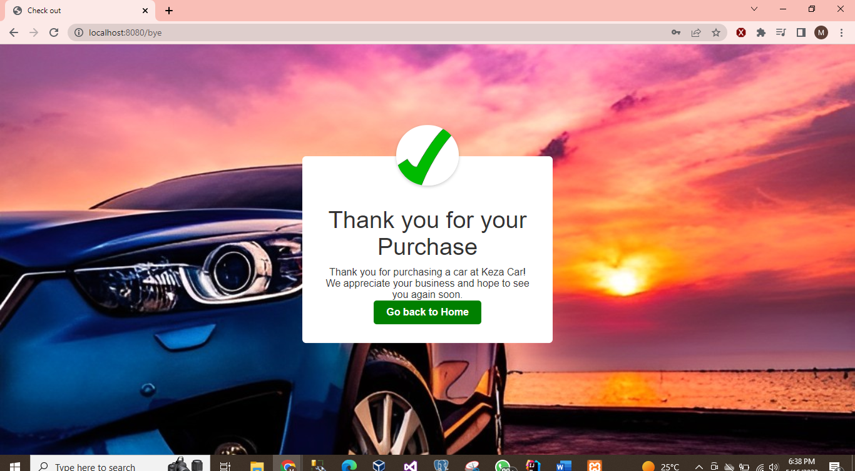

**Tables in the database:**

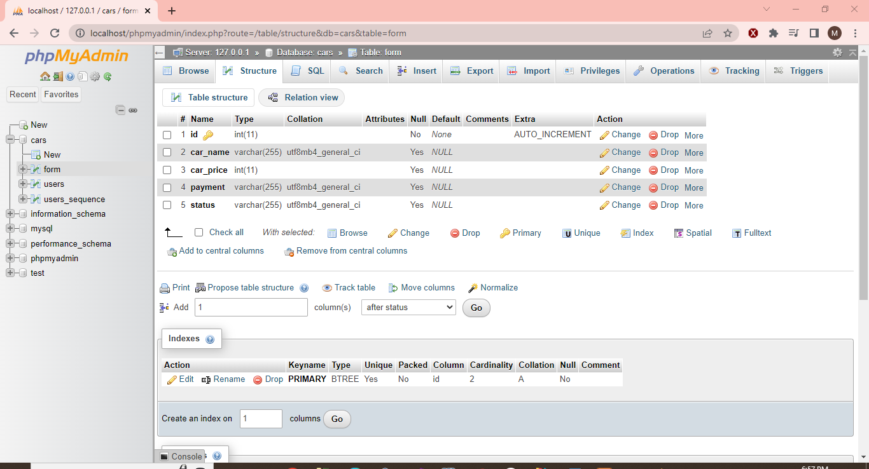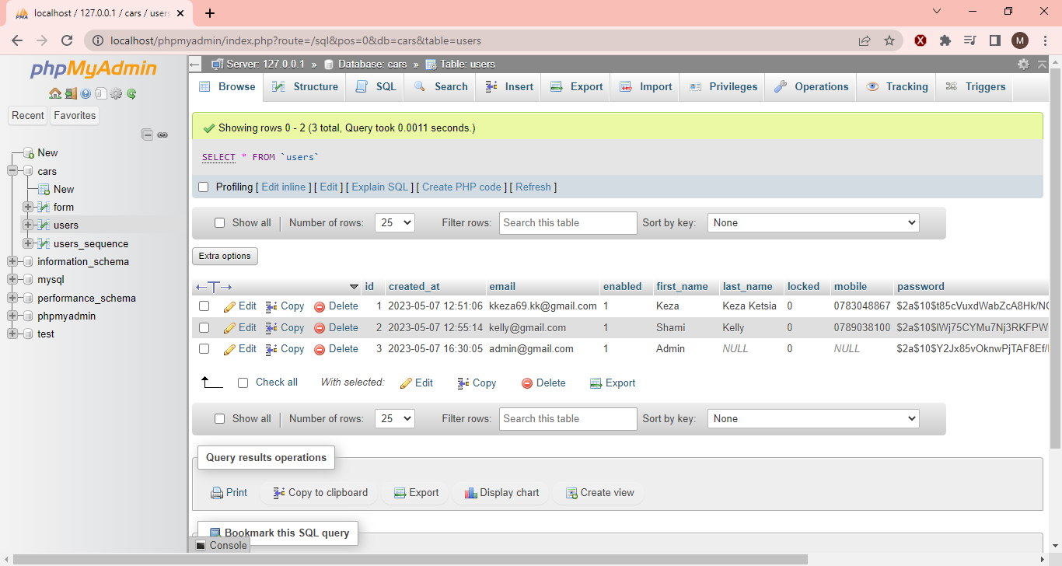

**Thank You! HAPPY NEW YEAR !!**